# **Let's Talk AI**

**Zoe's avatar**

[Zoe](https://substack.com/@zoeffc)

Jul 12, 2024

Share

Hi there!

We need to talk about AI. As young people in the workforce, I think that it is fair to assume that AI is going to be a feature of our future careers, whether we like it or not.

Today I want to… (a) break down what AI *is* as of this moment, (b) share ways that you might use or think about it in your current role, and (c) start playing with imagining what a future professional world that uses AI might look like and how we may be able to use that to our advantage.

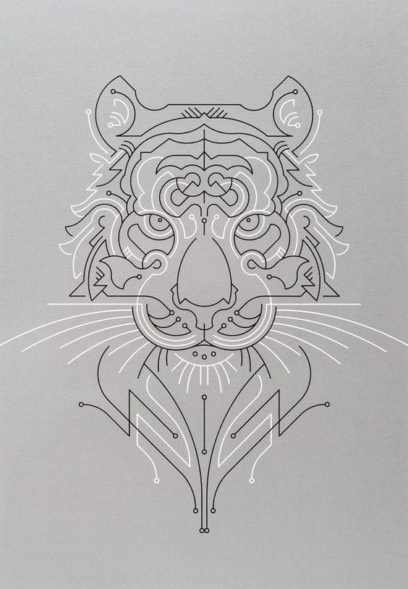

*Art by The Lost Fox*

Before I get ahead of myself — some housekeeping:

📫 If a friend forwarded you this newsletter (then you have some really cool friends), and you may want to consider joining us [*here*](https://femme-futures.beehiiv.com/subscribe) for regular updates.

🧲 Got some thoughts you want to share? Join us on [*Discord*](https://discord.gg/592wuyvx?utm_source=femme-futures.beehiiv.com&utm_medium=referral&utm_campaign=let-s-talk-ai) to chat all things newsletter and corporate life.

First things first — *what do I mean when I say “AI”?*

So, I am using “AI” — an abbreviation for “artificial intelligence” as shorthand for the more novel “large language models” (LLMs) that have become a feature of our modern world. This isn’t exactly right. IBM defines AI as “technology that enables computers and machines to simulate human intelligence and problem-solving capabilities.” That means a calculator is technically AI, as is Excel, grammar/spelling check, and GPS rerouting. Clearly, the professional world has figured out how to use those things.

IBM additionally explains that “Large language models (LLMs) are a category of foundation models trained on immense amounts of data making them capable of understanding and generating natural language and other types of content to perform a wide range of tasks.” That means things like ChatGPT, Microsoft Co-Pilot, and [*Claude.ai*](http://claude.ai/?utm_source=femme-futures.beehiiv.com&utm_medium=referral&utm_campaign=let-s-talk-ai) — where it gets interesting.

When ChatGPT 3.5 launched in November 2022, I was working as a grant writer for a nonprofit. Writer jobs were the ones that everyone worried would disappear first. I had the good fortune of working for a manager who pushed us to use ChatGPT 3.5 in our work so that we became familiar with the tool. My team discovered the limitations of that version, found ways to integrate it into our work, and learned how to spot LLM-generated language as opposed to human-written language. Then, when I was applying for jobs, I was able to make use of this knowledge. Suddenly, I had a tool that could erase blank-page paralysis in writing cover letters and compare my resume to whatever job description I was curious about.

If you are not already using AI in your personal and professional life, I challenge you to bring it to every problem that you face. Find which LLM you like the best (there are A LOT out there and some are better than others). Figure out how it fits with your skills. Find ways to outsmart it. Most importantly — add it to your resume. This is an invaluable and still rare skill set. If you learn it, you should benefit from the new knowledge.

It would be silly for me to suggest that I have any idea what the future of the public, private, and nonprofit sectors will look like once AI has had a few more years to infiltrate. Right now, learning the weaknesses of AI is the smartest thing that you can do. Older generations will have a harder time coming to the new technology and will be more put off by knowing that it has been used in a work product. The key is to use it and improve it. Have it do a first draft of your cover letter, and then edit it within an inch of its life.

The only way to ensure that your job will not be replaced by AI is to prove that you can use it to your advantage. Or choose a fully analog job — that would work too.

I know that I sound preachy this week. If this sounds interesting or exciting to you, play with it, if it doesn’t, continue as you were. I believe in you. You will figure this out.

Beep-boop-bop,

Zoe



*An AI-generated image!*

**

*AI-generated image!*

**Femme Futures Cooperative Founding Principles**

💚 **Mission**: The mission of Femme Futures is to create a community space for young professionals who identify as over-achievers and activists to generate collective success by providing resources and platforms to thrive in challenging workplace environments.

💙 **Vision**: To contribute to a world where driven individuals are equipped with the tools, guidance, and connections to overcome systemic barriers, fully utilize their talents, and enact positive change in their organizations and communities